**Task 9**

**OUTPUTS:**

**Number pattern:**

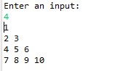

**Palindrome:**





**Reverse String:**

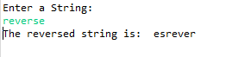

**Star pattern:**

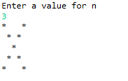

**Largest Number:**

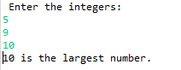

**HotelTariff:**

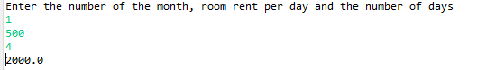

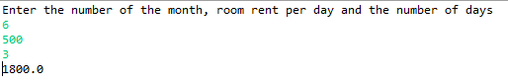

**Gradingsystem:**

